TEST REPORT

For

*E-Learning course and apps development of Light Engineering Sector for BTEB*

Ref: SD-38

Submitted By~

Olivine Limited

Innovative Ideas Led by Adroit

VERSION HISTORY

| **Version #** | **Implemented**  **By** | **Revision**  **Date** | **Approved**  **By** | **Approval**  **Date** | **Reason** |
| --- | --- | --- | --- | --- | --- |
| 1.0 | Rajan | 20/12/21 | Mohammad Samawat Ullah | 28/12/21 | Unit Testing Done |
| 2.0 | Hridoy | 16/01/22 | Mohammad Samawat Ullah | 03/02/22 | UAT |
|  |  |  |  |  |  |
|  |  |  |  |  |  |

**Table of Contents**

| **1.0** | **Purpose** | 4 |
| --- | --- | --- |
| **2.0** | **Test Summary** |  |
|  | 2.1 Unit Test | 4 |
|  | 2.2 Test Type (Function, Unit, System, etc.) | 4 |
| **3.0** | **Test Assessment** | 5 |
| **4.0** | **Test Results** |  |
|  | 4.1 Unit/ Module/ System Testing | 11 |
|  | 4.2 User Acceptance Testing | 11 |
| **5.0** | **Variances** | 13 |
| **6.0** | **Test Instances** | 13 |
|  | 6.1 Resolved Test Incidents | 13 |
|  | 6.2 Unresolved Test Incidents | 13 |
| **7.0** | **Recommendations** | 13 |
|  | **Appendix A: Test Report Approval** | 14 |
|  | **Appendix B: References** | 15 |

# 

# 1.0 INTRODUCTION

## 1.1 PURPOSE

This ‘Bangladeshi Restaurant Game‘ Test Report provides a summary of the results of a test performed as outlined within this document.

# 2.0 TEST SUMMARY

The test report summarized a robust brute force test to check overall functionalities, including unit test, UAT etc. in the unit test part we have tested all functionalities that were supposed to act as mentioned in the GDD and according to the design plan. However, UAT mainly focuses on end-user acceptance and focuses on design fixes working environment and better user experiences.

**Project Name**: Skill Development for Mobile Game and Application

**System Name**: Bangladeshi Restaurant Game

**Version Number**: 2.0

**Additional Comments**: N/A

# 2.1 unit test

We have planned and categorized Unit Testing Techniques mainly into three parts which are Black box testing that involves testing of user interface along with input and output, White box testing that involves testing the functional behavior of the software application and gray box testing that is used to execute test suites, test methods, test cases and performing risk analysis.

Code coverage techniques used in Unit Testing are listed below:

* Statement Coverage
* Decision Coverage
* Branch Coverage
* Condition Coverage
* Finite State Machine Coverage

**Test Owner**: Hridoy Chandra Deb

**Test Date**: 16/01/22- 03/02/22

**Test Results**: Most of the test cases passed through except few exceptions that were reported back for further development and fix. Moreover, fixed cases were tested in version-2 for final approval.

## 2.2 TEST TYPE (FUNCTION, UNIT, SYSTEM, ETC.)

At this stage of UAT, we initially Prepare UAT plan in the project life cycle. After that, a Checklist is prepared before the UAT starts. Besides, Pre-UAT session is conducted during the System Testing phase itself. Once the previous stage passed, we set the expectation and define the scope of UAT clearly. Finally, we test End to End business flow and avoid system tests. The following checklist's purpose is to ensure that the appropriate steps have been taken to execute a user acceptance test (UAT), to wrap up the process and ensure proper documentation has been completed. We choose "Yes, No or N/A" as it applies to the UAT process in the organization.

1. Review and analyze business and functional requirements.
2. Create test cases.
3. Run standard test cases and associated ad-hoc tests relevant to usability and acceptance criteria.
4. Log and report defects
5. Log and report usability comments, issues, or suggestions
6. Discuss defects and/or issues with your team.
7. Retest after any changes

# 3.0 TEST ASSESSMENT

For the Unit test and UAT to be effective, we have seen it as validation instead of verification. We considered this UAT in both large and small contexts. In the large context, test scenarios are an excellent way to simulate real-world processes. In the smaller context, test cases and/or test procedures are suitable for users to validate smaller scope functionality.

# 4.0 TEST RESULTS

The test results are listed below with a detailed explanation. Each case are based on a business requirement and use case and tested by both developer end (unit test) and end-user end (UAT) with a comment of being passed/failed

## UNIT/MODULE/SYSTEM TESTING

* **Test Case ID: 1**

Description: This function meets the expected result. And launch the game successfully.

Pass / Fail: Pass.

Test Case:

void Start () {

        if (puzzle != null)

        {

            // puzzle was set so get linked DemoJigsawPuzzle class

            jigsawPuzzle = puzzle.GetComponent("DemoJigsawPuzzle") as DemoJigsawPuzzle;

            if (jigsawPuzzle==null)

                 jigsawPuzzle = puzzle.GetComponent("DemoJigsawPuzzle_mac_ios") as DemoJigsawPuzzle_mac_ios;

            if (jigsawPuzzle==null)

                 jigsawPuzzle = puzzle.GetComponent("JSDemoJigsawPuzzle") as DemoJigsawPuzzle;

            if (jigsawPuzzle!=null)

                // if we have a jigsawPuzzle set size related to puzzleImage (1-3) and sizeMode (1-6)

                SetSize();

* **Test Case ID: 2**

Description: To test whether the game can add scores to the leaderboard. Only local authenticated user shall be able to add a score.

Pass / Fail: Fail.

Test Case:

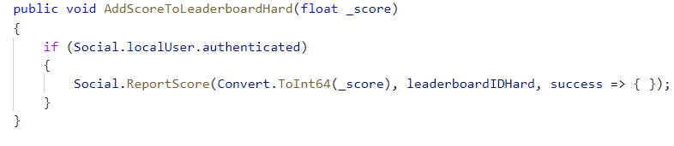

* **Test Case ID: 3**

Description: To test whether the game can control game sound or not. This function works fine to control game sound.

pass / Fail: Pass.

Test Case:

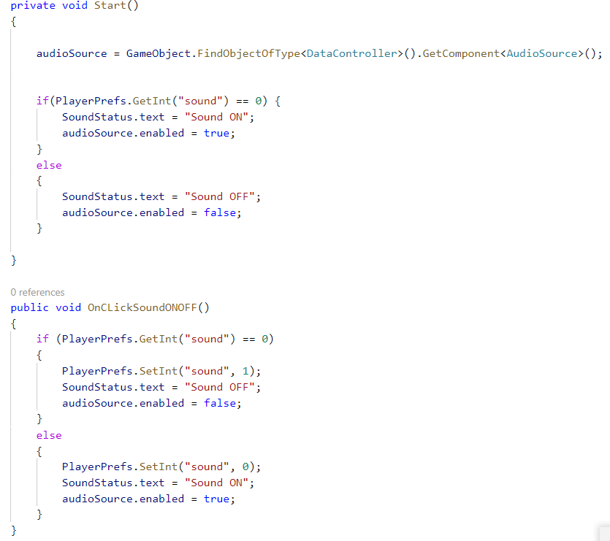

* **Test Case ID:4**

Description: To test whether a click on the restart button the game can restart or not. This function works fine and restarts the game successfully.

Pass / Fail: Pass

Test Case:

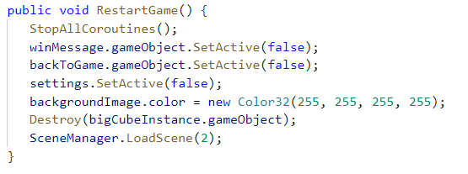

* **Test Case ID:5**

Description: To test this function, can it returns the game to the main menu or not. This worked fine and returned the game to the main menu.

Pass / Fail: Pass

Test Case:

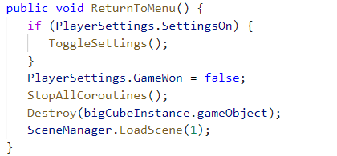

* **Test Case ID:6**

Description: To test after launching whether the game can save player progression or not. This function works and saves the player progression.

Pass / Fail: Pass

Test Case:

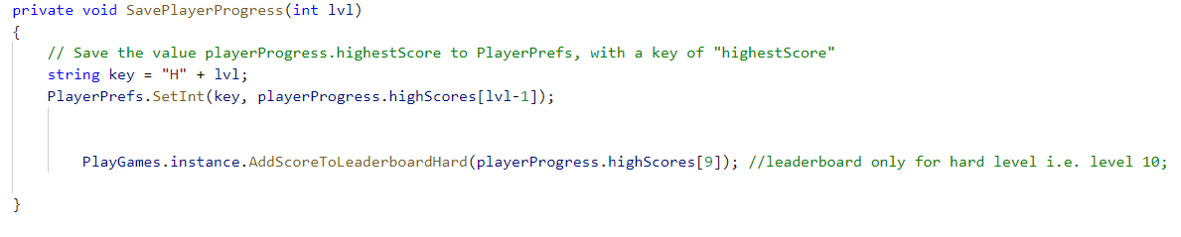

**Test Case ID:7**

Description: To check whether the game reset position after rotations the puzzle. These functions fulfil the desired result and reset it’s position.

Pass / Fail: Pass

Test Case:

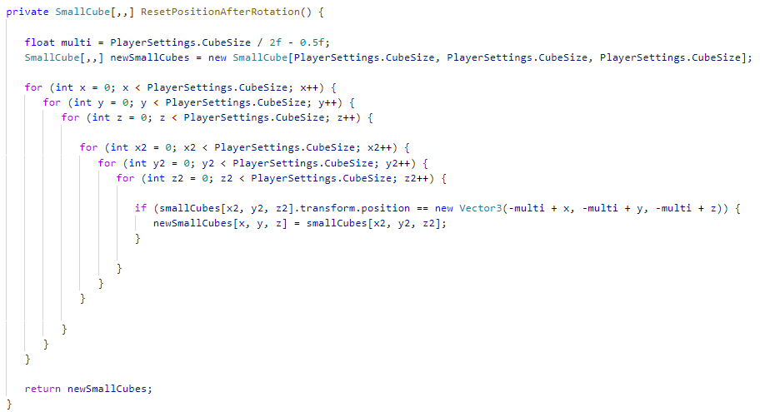

* **Test Case ID:8**

Description: To check whether the cube can change the direction. These functions work fine and changed the direction accurately.

Pass / Fail: Pass

Test Case:

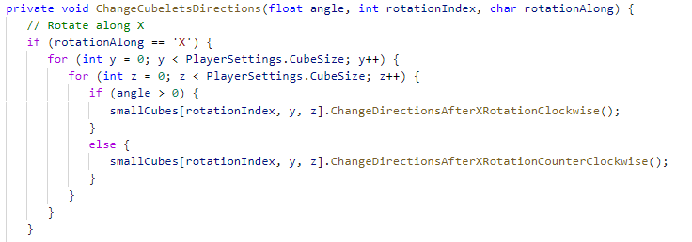

**Test Case ID:9**

Description: To check after finish the game can it show the game was won moment or not. These functions worked fine.

Pass / Fail: Pass

Test Case:

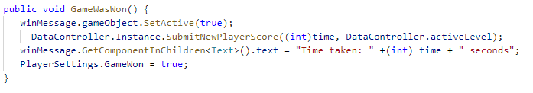

* **Test Case ID:10**

Description: To check whether the players can choose the difficulty level or not. These functions worked fine.

Pass / Fail: Pass

Test Case:

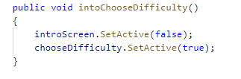

**Test Case ID:11**

Description: To check whether the game can show Achievement history or not.

Pass / Fail: fail

Test Case:

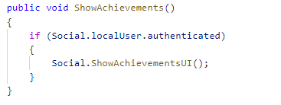

# 4.2 USER ACCEPTANCE TESTING

The table below summarizes the test cases employed for user acceptance testing and the test results obtained for each test case:

| Serial No: | Test Case ID | Test Case | Tester | Pass/Fail | Severity of Defect | Summary of Defect | Comments |
| --- | --- | --- | --- | --- | --- | --- | --- |
|  | 001 | Games launch successfully | Hridoy | Pass | N/A |  |  |
|  | 002 | User is able to control game sound | Hridoy | Pass | N/A |  |  |
|  | 003 | Should show leaderboard button | Hridoy | Pass | N/A |  |  |
|  | 004 | Should show time based leaderboard serial | Hridoy | Fail | Fail |  |  |
|  | 005 | Click back to Main menu | Hridoy | Pass | N/A |  |  |
|  | 006 | Click on Update. | Hridoy | pass | N/A |  |  |
|  | 007 | Click on Leaderboard | Hridoy | pass | N/A |  |  |
|  | 008 | Click on Mute button | Hridoy | pass | N/A |  |  |
|  | 009 | Click on Restart button | Hridoy | pass | N/A |  |  |
|  | 010 | Click on Next button | Hridoy | Pass | N/A |  |  |
|  | 011 | Puzzle piece move when touched | Hridoy | Pass | N/A |  |  |
|  | 012 | The flow of game is correct | Hridoy | Pass | N/A |  |  |
|  | 013 | Puzzle pieces fits the right position | Hridoy | Pass | N/A |  |  |
|  | 014 | The database for players scores is updating accordingly | Hridoy | Pass | N/A |  |  |
|  | 015 | Start button starts the game | Hridoy | Pass | N/A |  |  |
|  | 016 | Exit button closes the game and takes to mobile screen | Hridoy | Pass | N/A |  |  |
|  | 017 | Game music plays without any buffer or lag | Hridoy | Pass | N/A |  |  |
|  | 018 | Correct animations occur for certain clicks | Hridoy | Pass | N/A |  |  |
|  | 019 | The leaderboard menu shows 1 st 10 highest scorers | Hridoy | Pass | N/A |  |  |
|  | 020 | The leaderboard shows the rank, player name and score | Hridoy | Pass | N/A |  |  |
|  | 021 | User Interface Alignment is correct | Hridoy | Pass | N/A |  |  |
|  | 022 | Text header, main text are in right font | Hridoy | Pass | N/A |  |  |
|  | 023 | Every level is showing different puzzle | Hridoy | Pass | N/A |  |  |
|  | 024 | Every puzzle gets hard as the game proceeds | Hridoy | Pass | N/A |  |  |

# 5.0 VARIANCES

Any variances between the testing that was planned and the testing that actually occurred. Also, provide an assessment of the manner in which the test environment may be different from the operational environment and the effect of this difference on the test results.

# 6.0 TEST INSTANCES

Provide a brief description of the unexpected results, problems, or defects that occurred during the testing.

## RESOLVED TEST INCIDENTS

All resolved test incidents and summarize their resolutions. Reference may be made to Test Incident Reports that describe in detail the unexpected results, problems, or defects reported during testing, along with their documented resolutions, which may be included as an appendix to this document.

## UNRESOLVED TEST INCIDENTS

All unresolved test incidents and provide a plan of action for their resolution. Reference may be made to Test Incident Reports that describe in detail the unexpected results, problems, or defects reported during testing, which may be included as an appendix to this document.

# 7.0 RECOMMENDATIONS

A discussion of each recommendation and its impact on the business product may be provided. If there are no recommendations to report, then simply state as such.

**APPENDIX A: Test Report Approval**

The undersigned acknowledge they have reviewed the ‘**Bangladeshi Restaurant Game’** **Test Report** and agree with the approach it presents. Changes to this **Test Report** will be coordinated with and approved by the undersigned or their designated representatives.

| Signature: | SD-Pomerul | Date: | 10-06-2021 |
| --- | --- | --- | --- |
| Print Name: | Pomerul Islam |  |  |
| Title: |  |  |  |
| Role: | Project Manager |  |  |

**APPENDIX B: REFERENCES**

The following table summarizes the documents referenced in this document.

| **Document Name and Version** | **Description** | **Location** |
| --- | --- | --- |
| UAT Checklist | UAT checklist followed by testing team | Attached |

